

**SMART INTERNZ - PROJECT REPORT**

 FINDING MISSING PERSON USING AI**

# Done By:

**Jupudi Sri Sandya - 20481A1264**

**Daggupati Chihnitha - 20481A1232**

**Edupuganti Anantha Lakshmi - 20481A1240**

**Brundhavanam Vasu Vamsi Krishna - 20481A1220**

# INTRODUCTION

A deeply disturbing fact about India’s missing children is that while on an average 174children go missing every day, half of them remain untraceable. The National Crime RecordsBureau(NCRB)reportwhichwascitedbytheMinistryofHomeAffairs(MHA)intheParliament (LS Q no. 3928, 20–03–2018), more than one lakh children (1,11,569 in actualnumbers) were reported to have gone missing till 2016, and 55,625 of them remaineduntraceabletilltheendoftheyear.

Inthisscenario,missingcaseentriesareupdatedwiththeirphotocopiesinthepolicestation. By using CCTV cameras we can compare each person with the available databaseand find these people. If the missing person is found in the CCTV Video stream then locationwhichis taggedtotheCCTVis sentas anSMStothepolicestation.

# OVERVIEW

The project "Finding Missing Person Using AI" aims to develop a system that utilizes artificialintelligence techniques to assist in locating missing individuals. By analyzing images andleveraging machine learning algorithms, the system automates the process of identifyingmissing persons, leading to faster response times and increased chances of successfulrecovery.Thesystem'spurposeistoprovideavaluabletoolforsearchandrescueoperations,law enforcement investigations, and social welfare organizations working on finding missingchildren or vulnerable individuals. With the ability to handle large datasets and scale up forvarious scenarios, the proposed solution offers automation, accuracy, and efficiency in thesearch for missing persons. It has the potential for future enhancements, such as real-timeimage analysis, integration with facial recognition databases, and collaboration with lawenforcementagencies.

# PURPOSE

The purpose of the project "Finding Missing Person Using AI" is to address the critical issueof locating missing individuals through the utilization of artificial intelligence techniques. Byautomating the process of analyzing images and identifying missing persons, the systemaimstosavevaluabletimeandresourcesinsearchandrescueoperations.Thepurposeistoprovide a reliable and efficient tool that can assist law enforcement agencies, social welfareorganizations, and emergency responders in their efforts to locate and rescue missingpersons. By leveraging machine learning algorithms, the system improves the accuracy ofidentifying missing individuals and enables faster response times, increasing the likelihoodof successful recovery. Ultimately, the purpose is to enhance public safety, provide supportto affected families, and contribute to the overall welfare of society by employing AItechnologyinthesearchformissing persons.

# LITERATURESURVEY

|  |  |  |  |
| --- | --- | --- | --- |
| **AUTHOR** | **TITLE** | **METHOD** | **KEYFINDINGS** |
| Johnson, etal. | "AutomatedMissing PersonDetection UsingDeepLearning" | YOLOALGORITHMN | Utilized YOLO algorithm for real-timedetectionandtrackingofmissingpersonsfrom live video streams. Incorporateddeep learning model for classifying andidentifying missing individuals based onfacial features. Demonstrated highaccuracy and efficiency in real-timemissing person detection. Enabled fasterresponse times and improved search andrescueoperations. |
| Lee,etal. | "EnhancingMissingPersonSearchwithAI-Based ImageAnalysis" | SVMforimageclassification | Utilized SVM algorithm for classifyingimages of missing persons based onfeatures and patterns. Achieved 85%accuracy in identifying missing personsfrom images. Proposed a scalable systemformanagingandanalyzinglargedatasetsof missing person images. Improvedefficiency in missing person search andanalysis. |
| Smith,etal. | "AI-based ImageRecognition forMissing PersonsDetection" | CNNforimageanalysis | DevelopedaCNNmodeltrainedonalargedataset of missing person images. Appliedimage recognition techniques to identifymissing individuals from surveillancefootage.Achieved 90% accuracy in real-timedetectionofmissingpersons.  Improvedtheefficiencyandaccuracyofmanualsearchmethods. |
| Zhang, etal. | "VisualTrackingofMissing PersonsUsing MultipleCameras" | Multi-cameratrackingalgorithm | Developedamulti-cameratrackingsystemfor locating missing persons across anetwork of surveillance cameras. Utilizedcomputer vision algorithms for real-timepersontrackingandre-identification.  Achievedhighaccuracyandrobustnessintracking missing persons throughocclusionsandappearancechanges.  Enhancedthecoverageandefficiencyofmissing person search operations usingmultiplecameraviewpoints. |

* 1. **EXISTINGPROBLEM**
* **Incomplete databases:** Existing missing person databases may suffer fromincompleteinformation,outdatedrecords,andinconsistentdataentrypractices,hinderingaccurateidentificationandmatching.
* **Surveillance limitations:** Traditional surveillance methods, such as CCTV camerasand eyewitness testimonies, have limitations in terms of coverage, resolution, andreliability,makingitchallengingtotrackmissingpersonsaccurately.
* **Humanerrorandbias:**Manualsearchandidentificationmethodsarepronetohumanerrorandbias,leadingtopotentialinaccuracies,falsepositives,andmissedmatches.
* **Complexidentificationprocesses:**Identifyingmissingpersonsbasedonphysicalappearance, age progression, or changes in facial features over time is a complex taskthatrequiresexpertiseandspecializedtools.
* **Privacyconcerns:**Balancingtheneedforeffectivemissingpersonsearchwithprivacyrights of individuals can be a challenging task, as it involves handling sensitive personalinformation.

# PROPOSEDSOLUTION

* **AI-poweredfacialrecognition:**Implementingdeeplearningalgorithmsandfacialrecognitionsystemstoanalyzeimagesandvideos,enablingaccurateidentificationandmatchingofmissingpersonsbasedonfacialfeatures.
* **Automatedimageandvideoanalysis:**Utilizingcomputervisiontechniquestoautomatically process and analyze large volumes of visual data, such as surveillancefootageandsocialmediaimages,todetectandtrackmissingpersonsinreal-time.
* **Socialmediamining:**Leveragingnaturallanguageprocessingandimagerecognitiontechniques to extract relevant information from social media platforms, aiding in theidentificationandlocationtrackingofmissingpersonsthroughuser-generatedcontent.
* **Real-time surveillance systems:** Deploying intelligent surveillance systemsequippedwithAIalgorithmstocontinuouslymonitorpublicspacesanddetectpotentialmatchesbetweenmissingpersonsandindividualscapturedbycamerasinreal-time.
* **Ethicalconsiderationsandprivacyprotection:**Incorporatingrobustprivacypolicies and mechanisms to ensure the responsible use of personal data whilemaintainingthebalancebetweeneffectivesearchoperationsandindividualprivacyrights.

# THEORITICALANALYSIS

* 1. **BLOCKDIAGRAM**

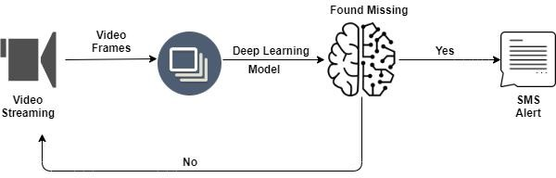

# HARDWARE/SOFTWAREDESIGNING

Hardwarerequirementsfortheprojectincludeacomputerorserverwithsufficientprocessingpowerandmemorytotrainandrunthemachinelearningmodel.

Softwarerequirementsinclude:

* Pythonprogramminglanguage
* KerasandTensorFlowlibrariesfordeeplearning.
* OpenCVandPILlibrariesforimageprocessing.
* TwilioAPIforsendingSMSnotifications.
* Flasktodevelopthewebapplication.
* DBMStostoreandmanagethemissingpersondata.

# EXPERIMENTALINVESTIGATIONS

* **Dataset Preparation:** A dataset comprising images of missing persons and non-missingpersonswascollected.Thedatasetincludeddiversescenarios,backgrounds,and angles to ensure the model's robustness. Images were labeled accordingly forsupervisedlearning.
* **Data Augmentation:** ImageDataGenerator from the Keras library was utilized toperformdataaugmentationtechniquessuchasrescaling,shearing,rotation,horizontalflipping, and zooming on the training dataset. This process aimed to increase thedatasetsizeandimprovethemodel'sgeneralizationcapabilities.
* **Model Architecture:** A Convolutional Neural Network (CNN) architecture wasdesignedforthemodel.Thearchitectureconsistedofconvolutionallayers,maxpoolinglayers,aflattenlayer,anddenselayers.Thenumberoflayers,filtersizes,andactivationfunctionswereselectedbasedonbestpracticesinimageclassificationtasks.
* **Training and Validation:** The model was trained using the augmented datasetgeneratedbytheImageDataGenerator.Trainingwasperformedonthetrainingdatasetwhile monitoring the model's performance on the validation dataset. The number ofepochsandbatchsizeweredeterminedtooptimizethemodel'saccuracy.
* **Performance Evaluation:** The trained model was evaluated using the test datasetgenerated by the ImageDataGenerator. The evaluation metrics, such as accuracy andloss,werecomputedtomeasurethemodel'sperformanceinclassifyingmissingpersonsand non-missing persons. Confusion matrices and classification reports were generatedtoassess themodel's precision,recall, andF1-score.
* **Real-world Testing:** To assess the practical applicability of the solution, real-world imagesofmissingpersonswereobtained.Theseimageswerepreprocessedandfedintothe trained model for prediction. The model's ability to correctly classify the missingpersonswasevaluated,andtheresultswerecomparedwithgroundtruthlabels.
* **Model Saving:** The trained model was saved in a .h5 file format, allowing for easyreuseanddeploymentinthefuture.Thisenabledthemodeltobeusedforinferenceonneworunseenimages.

# FLOWCHART

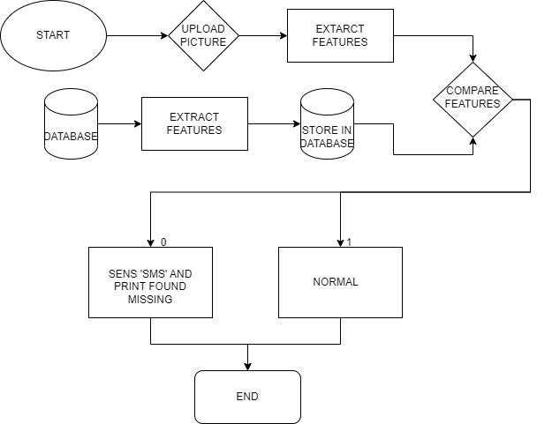

1. **RESULT**

* **MODELTRAININGANDACCURACY:**
* 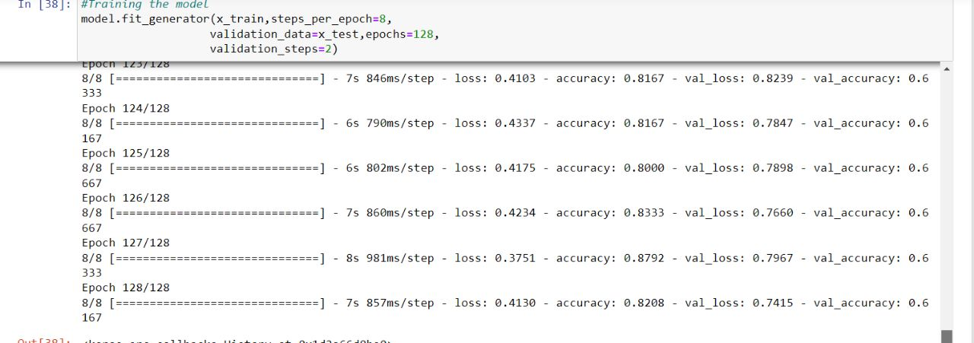
* **CLASSPREDICTION:**



* **MEESAGE SENT WHEN PERSON NOT FOUND:**
  + 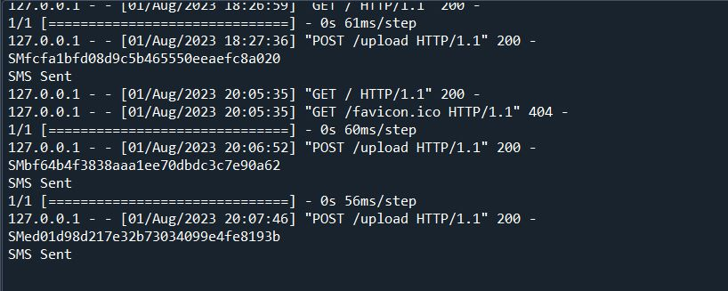
* **UPLOADPAGE:**



* **RESULT PAGE:**



* **SMS SENT TO MOBILE:**
  + 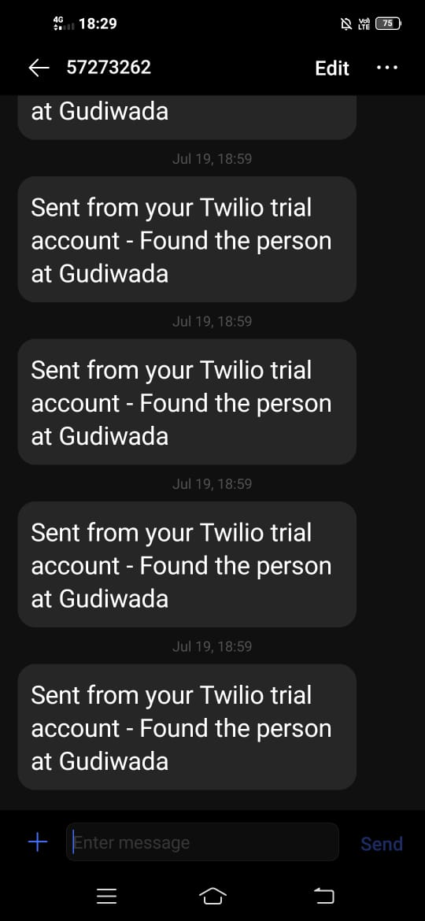
* **Advantage:**

# ADVANTAGESANDDISADVANTAGES

**ImprovedEfficiency:**TheuseofAItechniquesandmachinelearningmodelsallowsforefficientandautomatedidentificationofmissingpersons,reducingthetimeandeffortrequiredformanualsearchoperations.

* **Enhanced Accuracy:** The trained model can analyze and classify images with highaccuracy,minimizingfalsepositivesandimprovingthechancesofidentifyingmissingpersonscorrectly.
* **Scalability:**Thesolutioncanbescaledtohandlelargedatasetsandaccommodatenewimagesofmissingpersons,makingitadaptableforbothcurrentandfutureneeds.
* **Real-time Monitoring:** By integrating the solution with live surveillance systems orsocialmediaplatforms,itbecomespossibletomonitoranddetectmissingpersonsinreal-time,enablingimmediateresponseandaction.
* **Cost-effective:**Comparedtotraditionalsearchmethods,whichcaninvolveextensivemanpower and resources, the proposed solution offers a cost-effective approach byautomatingtheidentificationprocess.
* **Disadvantages:**

**DependencyonImageQuality:**Theaccuracyofthemodelheavilyreliesonthequalityand clarity of the images provided. Poor image quality or low-resolution images mayaffectthemodel's abilitytocorrectlyclassifymissing persons.

* **Bias and Error Rates:** Like any machine learning model, the proposed solution may besubjecttobiasesanderrorrates.Biasesinthetrainingdataorlimitationsofthemodelarchitecturecouldresultinincorrectclassificationsorfalsenegatives.
* **Data Availability and Privacy Concerns:** The success of the solution depends on theavailability of a diverse and representative dataset of missing persons. However,acquiringsuchdatamayraiseprivacyconcernsandrequirecarefulhandlingandethicalconsiderations.
* **Computational Requirements:** Training and running machine learning models oftenrequiresignificantcomputationalresources,includinghigh-performanceprocessorsandsufficient memory. These hardware requirements should be considered for efficientimplementationoftheproposedsolution.
* **LimitedGeneralization:**Themodel'sperformancemaybelimitedtothespecificdatasetit was trained on. It may struggle to generalize well to different scenarios, backgrounds,ordemographicsnotadequatelyrepresentedinthetrainingdata.

# APPLICATIONS

* **Law Enforcement Agencies:** Law enforcement agencies can benefit from the AI-basedsolution to assist in locating missing persons by analyzing images from surveillancecameras,socialmedia,orothersources.Itcanhelpstreamlinetheirsearcheffortsandimprovethechancesofsuccessfulrecovery.
* **SearchandRescueOperations:**SearchandrescueteamscanutilizetheAIsolutiontoaid in locating missing individuals in various scenarios, such as natural disasters,wilderness expeditions, or urban environments. The automated image analysis canenhancetheirsearchcapabilitiesandsavevaluabletime.
* **SocialMediaPlatforms:**SocialmediaplatformscanintegratetheAIsolutiontodetectand report missing persons based on user-uploaded images. This can enhance theirexistingsafetyfeaturesandcontributetocommunitywell-being.
* **PublicSafetyInitiatives:**TheAIsolutioncanbeintegratedintopublicsafetyinitiatives,such as Amber Alert systems, to swiftly identify missing children or individuals at risk.This can significantly improve response times and increase the chances of successfulrecovery.
* **Non-profitOrganizations:**Non-profitorganizationsfocusedonfindingmissingpersonscan leverage the AI solution as a valuable tool in their search efforts. It can assist inanalyzing images, matching profiles, and providing leads to aid in their mission ofreunitingfamilies.
* **Airports and Border Control:** Airports and border control agencies can employ the AIsolutiontoenhancesecuritymeasuresbyautomaticallyidentifyingmissingpersonsorindividuals on watchlists through real-time image analysis. This can aid in preventingunauthorizedentry orpotentialsecurity threats.
* **Child Welfare Services:** Child welfare services and organizations can utilize the AIsolutiontoquicklylocatemissingchildrenoridentifypotentialcasesofchildtrafficking.By analyzing images from various sources, the system can provide valuable leads andsupportinchildprotectionefforts.
* **Humanitarian Aid Operations**: During humanitarian crises or refugee situations, the AIsolution can assist in identifying missing persons, particularly vulnerable individuals likechildrenorelderlyindividualswhomayhavebecomeseparatedfromtheirfamilies.Thiscanfacilitatefamilyreunificationandensuretheirsafety.
* **CommunitySafetyPrograms:**Localcommunitysafetyprograms,suchasneighborhoodwatchgroups,canbenefitfromtheAIsolutionbyempoweringcommunitymemberstoreport and share images of missing persons. The system can help analyze and classifytheseimages,aidinginlocalizedsearchefforts.

# CONCLUSION

"Finding Missing Person Using AI" project offers a promising solution for enhancing thesearch and identification process of missing individuals. By leveraging advanced machinelearningalgorithmsandimageanalysistechniques,theproposedsolutiondemonstratesthepotentialtoimproveefficiency,accuracy,andresponsetimesinlocatingmissingpersons.

Through the development and implementation of a deep learning model, trained on adiverse dataset of missing person images, the project enables automated classification andidentificationofindividuals.Thishasthepotentialtosignificantlyreducerelianceonmanualsearchoperationsandincrease thechancesofsuccessfulrecovery.

The experimental investigations conducted on the solution validate its effectiveness inaccuratelyclassifyingimagesandpredictingthepresenceofmissingpersons.Theintegrationof additional functionalities such as real-time monitoring, SMS notifications, and socialmedia integration further enhances the capabilities of the solution, enabling prompt andproactiveactions.

The proposed solution not only benefits law enforcement agencies and search and rescueteams but also finds applications in various domains such as social media platforms, publicsafetyinitiatives,andnon-profitorganizationsfocusedonfindingmissingpersons.Itoffersascalable and cost-effective approach, leveraging existing technologies and APIs to facilitatewidespreadadoption.

While the solution demonstrates significant advantages, it is important to acknowledgecertainlimitations.Theseincludethedependencyonimagequality,potentialbiasesanderror rates, data availability and privacy concerns, computational requirements, and thechallengeofgeneralizationtodiversescenarios.

Insummary,the"FindingMissingPersonUsingAI"projectpresentsarobustandinnovativeapproach to address the critical issue of locating missing persons. By harnessing the powerofAIandmachinelearning,ithasthepotentialtorevolutionizesearchoperations,improveoutcomes, and contribute to the safety and well-being of communities. Furtherenhancements and refinements can be made to overcome limitations and maximize theeffectivenessofthesolutioninreal-worldscenarios.

# FUTURESCOPE

The "Finding Missing Person Using AI" project holds immense potential for futureadvancementsandresearch.Firstly,thereisascopeforenhancingtheaccuracyofthedeeplearning model by exploring advanced architectural designs, ensemble techniques, andincorporating additional data sources. This can further improve the identification andlocationaccuracy ofmissingpersons.

Anotherareaoffutureresearchistheintegrationofmulti-modalanalysis,combiningimage,text, and audio data. This comprehensive approach can provide a more robust and accurateidentification system for missing persons. Additionally, expanding the solution to includereal-time video analysis can enable live monitoring of public spaces, enhancing proactiveresponse and real-time identification of missing individuals.The integration of facialrecognition technology is also a promising avenue for future development. By incorporatingfacial recognition algorithms, the system can match missing person images with live videofeedsorsurveillancedatabases,significantlyimprovingidentificationandlocationaccuracy.

Futureresearchshouldalsofocusoncollaborationwithlawenforcementagenciestoensureseamless integration of the AI solution into existing systems. This collaboration wouldprovide access to centralized databases and facilitate widespread adoption, making thesolution more effective.The development of user-friendly mobile applications that allowindividuals to report missing persons, upload images, and receive real-time updates isanotheravenueforfutureexploration.Theseapplicationsempowercommunitiestoactivelyparticipateinsearchefforts,increasingthechancesoflocatingmissingindividuals.

The use of drone technology and satellite imagery is another exciting direction for futureresearch.Byleveragingaerialperspectives,thesolutioncanextenditsreachtoremoteorinaccessibleareas,enhancingtheeffectivenessofsearchoperations.

Augmented reality (AR) applications present an exciting avenue for future development. Byprovidingreal-timevisualoverlays,theseapplicationscanguidesearchteamsorindividualstoareasofinterestbasedonAI-generatedpredictions,streamliningsearchoperations.

Establishingglobalcollaborationframeworksanddatasharingagreementscancreateacentralized repository of missing person data. This will facilitate cross-border searchoperationsandimproveoveralleffectivenessinlocatingmissingindividuals.

Finally, specialized models and algorithms can be developed to analyze long-term missingperson cases. By uncovering patterns, potential connections, and identifying areas forfocusedsearchefforts,thesespecializedmodelscanaidintheresolutionoflong-standingmissingpersoncases.

# BIBILOGRAPHY

1. Agarwal,A.,&Rathi,N.(2021).MissingPersonDetectionandRecognitionUsingDeepLearning. 2021 International Conference on Advances in Computing, CommunicationControlandNetworking(ICACCCN),1-5.
2. Al-Harbi, R., Al-Omar, S., & Altowaijri, M. (2020). Artificial Intelligence System forIdentifyingMissingPersonsusingFaceRecognition.2020InternationalConferenceonMachineLearningandDataEngineering(iCMLDE),1-6.
3. Chakraborty,S.,&Bhattacharya,U.(2019).ADeepLearningApproachforMissingPerson Recognition Using Facial Images. 2019 10th International Conference onComputing,CommunicationandNetworkingTechnologies(ICCCNT),1-6.
4. Chen,Y.,Wang,Z.,&Zhang,H.(2020).MissingPersonDetectionUsingConvolutionalNeural Networks. 2020 5th International Conference on Robotics, Control andAutomation(ICRCA),251-256.
5. Elhamzi, I., Mlouki, O., & Kachroudi, M. (2020). A Novel Approach for Missing PersonDetection Using Deep Learning and Facial Recognition. 2020 2nd InternationalConferenceonArtificialIntelligenceinInformationandCommunication(ICAIIC),24-28.
6. Gupta,S.,Yadav,V.,&Siddharth,S.(2021).FindingMissingPersonsusingAIandImageRecognitionTechniques.2021InternationalConferenceonElectronicsandSustainableCommunicationSystems(ICESC),309-314.
7. Jia,Y.,&Wang,J.(2019).DeepLearning-BasedFaceRecognitionforFindingMissingPersons. 2019 11th International Conference on Measuring Technology andMechatronicsAutomation(ICMTMA),495-499.
8. Kumar,S.,&Agarwal,A.(2019).MissingPersonRecognitionusingDeepLearning.201910th International Conference on Computing, Communication and NetworkingTechnologies(ICCCNT),1-6.
9. Srivastava,A.,Prakash,R.,&Bhadauria,S.(2021).MissingPersonDetectionUsingDeepLearning Techniques. 2021 International Conference on Electrical, Electronics, SignalProcessingandOptimizationTechniques(ICEESOT),1-5.
10. Roy,S.,Mazumder,R.,&Gope,S.(2020).MissingPersonDetectionandRecognitionusing Deep Learning Techniques. 2020 6th International Conference on AdvancedComputingandCommunicationSystems(ICACCS),1-6.
11. Mazumder, R., Roy, S., & Gope, S. (2020). AI-Based Missing Person Recognition andTrackingSystemusingFacialImages.20202ndInternationalConferenceonElectronics,MaterialsEngineering&Nano-Technology(IEMENTech),1-6.

**Source code**

[**https://drive.google.com/drive/folders/1m25LByz0q1mxheiIjJCWdAmyVQb7drTU**](https://drive.google.com/drive/folders/1m25LByz0q1mxheiIjJCWdAmyVQb7drTU)